APPLICATION FORM FOR PARTICIPATION IN TRAINING PROGRAMME
(To be sent directly to the Director, DRWA)

1. Full Name (in Block Letters): __________________________________________________________
2. Designation : __________________________________________________________
3. Discipline : __________________________________________________________
4. Present Employer & Address: _________________________________________________________
______________________________________________________________________________________________
5. E-mail ID : __________________________________________________________
6. Mobile No. : __________________________________________________________
7. Sex : (Male/Female)_________________________________________
8. Marital Status : (Married/Unmarried)_________________________________
9. Date of Joining ARS : __________________________________________________________

Certificate -
It is certified that the information furnished above is correct.

Date:
Place: Signature of the applicant

13. Recommendation of forwarding Institute

Signature with Seal

Training Programme
Strengthening Gender Perspective in Agriculture Research & Development

18th - 27th September 2014

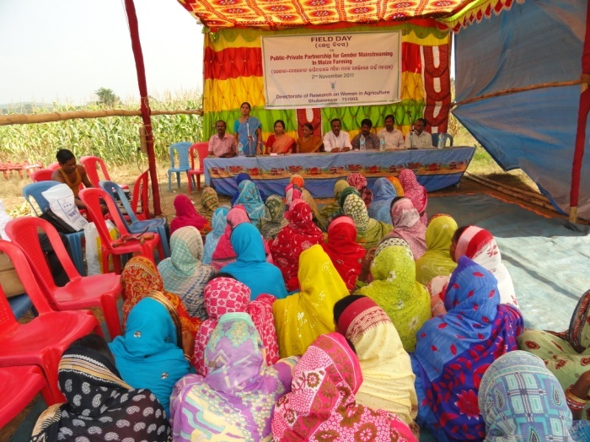

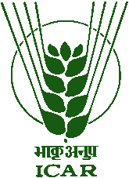

Organized by
Directorate of Research on Women in Agriculture (DRWA)
Bharatpur Square, Opp: Kalinga Studio, P.O.- Baramunda
Bhubaneswar – 751 003, Odisha
Website: www.drwa.org.in

BACKGROUND
Women have been contributing enormously to agricultural growth and development through their involvement in crop production, horticulture, animal husbandry, fisheries, natural resource management etc. Though the proportion of women workers in agriculture has declined, yet they constitute a significant workforce in agriculture globally constituting more than 42% of economically active population in agriculture. Region-wise figures show that agriculture supports a very high proportion of economically active women, particularly in Asia and Africa and in India it is about 62%. Women’s contribution varies across regions, socio-cultural and agro-production systems. In crops like rice, groundnut, horticulture and livestock it is very high but in fisheries, women contribute more in post harvest operations like grading and processing. Similarly, in plantation crops like tea, spice crops women's involvement is more than that of men as is the case in North Eastern region and tribal belts. On the other hand, the persisting gender gap in access to and control of resources remains an important concern which has not only kept women in a vicious circle of low productivity but also has thrown up questions about inclusive and sustainable growth of the sector. To bridge the gender gap and empower women with new knowledge and technology is a challenge. Many other issues concerning women in agriculture include valuation of women’s contribution, creating attractive opportunities in agriculture, developing gender sensitive extension approaches, methodologies and policies in agriculture etc. In order to address all these issues, agricultural research needs to be reoriented by including gender perspective and create an environment that supports its engendering. The National Consultation on Gender Perspective in Agriculture held in August 2011 and the first ever Global Conference on Women in Agriculture (GCWA) held in March 2012 at NASC complex, New Delhi also recommended gender sensitization of agri-researchers and integration of gender in agricultural research to generate evidences on gender based outcomes of R&D interventions.

Against this backdrop the training programme titled ‘Strengthening gender perspective in agricultural research and development' has been planned for scientists, particularly new young entrants into ARS.

OBJECTIVES
- Orient the agricultural scientists to the concept of gender and its importance in agriculture
- Help participants understand and identify gender issues in their own domains
- Expose participants to different gender analysis tools, statistical analysis of gender disaggregated data
- Enable scientists integrate gender perspective in their research projects and document the gender based outcomes

SALIENT COURSE CONTENTS
- Gender and gender related concepts
- Gender, agriculture and development
- Gender sensitization
- Gender analysis tools & techniques
- Gender disaggregated data – importance and analysis
- Gender issues in agriculture
- Gender and agricultural research

FACULTY AND TRAINING METHODOLOGY
The Training Programme would comprise lectures from well qualified and experienced scientists from DRWA and special guest lectures from eminent scientists/faculty from ICAR, SAUs and other reputed organizations. Additionally, group exercises, interactive sessions with stakeholders, field visits will also form part of the programme.

VENUE & DURATION
The Training Programme will be organized at DRWA, Bhubaneswar. The duration of the training will be for a period of 10 days from 18th to 27th September 2014.

FACILITIES AVAILABLE
- Research farm of about 15 acres under horticulture, field crops as well as livestock & fisheries covering experiments under various disciplines are available at the Institute. The Institute has developed demonstration units for various agro-enterprises

- A modern library with more than 2000 books/research journals/ CAB CD ROM Data base, Agricola data base, with various aspects of gender in agriculture
- AKMU with facilities of internet and data analysis software’s like SAS, etc.
- A conference hall with seating capacity of 150 persons and two committee rooms with seating capacity of 40 each besides a well equipped training hall and Gender data centre with the provision of LCD/ overhead projector/slide projector/ and other audio-visual aids

ELIGIBILITY AND REGISTRATION
Young and newly recruited ARS Scientists working in ICAR Institutes, preferably, having less than five years of experience may apply for the Training Programme. Duly filled application may please be sent to the Director, DRWA through email on or before 3rd September, 2014.

SELECTION AND CONFIRMATION OF PARTICIPANTS
Maximum 25 participants will be selected for the course. Candidates will be shortlisted based on first-come-first serve basis and intimation will be sent to the selected participants through E-mail.

TRAVEL, BOARDING AND LODGING
TA including boarding and lodging charges will be borne by the sponsoring organizations. The Directorate has a training hostel located in the campus of Directorate of Water Management (DWM), Chandrasekharpur, Bhubaneswar with limited number of beds. If needed, accommodation will be made in the hotels.

HOW TO REACH
Bhubaneswar is well connected by air/ rail/ road from all major cities of India. The Directorate is located near Bharatpur square (Baramunda) which is about 12 km from Bhubaneswar Railway station and 10 km from Airport.

IMPORTANT DATES
Last date for receipt of nomination: 3rd September 2014
Last date of intimation of selection: 4th September 2014

CONTACT DETAILS
Director  Dr. Neelam Grewal  Programme Directors  Dr. H.K. Dash  Dr. Sabita Mishra  Programme Coordinators  Dr. Abha Singh  Dr. J. Charles Jeeva  Dr. Ananta Sarkar | Directorate of Research on Women in Agriculture  Bharatpur Square, Opp: Kalinga Studio,  P.O.Baramunda  Bhubaneswar-751003, Odisha  Website: www.drwa.org.in  Email: nrcwa@nic.in  (copy to hkdash_nrcwa@yahoo.co.in)  Phone: 0674-2386220, Fax: 0674-2386242  Mobile: 098611 70169; 093372 35147; 093371 16845

